Copyright for test papers and marking guides remains with West Australian Test Papers.
Test papers may only be reproduced within the purchasing school according to the advertised Conditions of Sale.
Test papers should be withdrawn after use and stored securely in the school until Friday June 15th 2018.


MATHEMATICS
SPECIALIST
UNIT 3

Semester One

2018

SOLUTIONS

Calculator−free Solutions

1. Since $z=±2$ are roots, then $z^{2}-4$ is a factor.
$∴$ dividing $P(z)$ by $z^{2}-4$ gives the quadratic factor $2z^{2}-4z+4$
and using the quadratic formula gives $z=1±i$
$∴P\left(z\right)=2\left(z+2\right)\left(z-2\right)\left(z-1-i\right)\left(z-1+i\right)$ [5]

2. (a) $w=z^{3}={\left[3\operatorname{cis}\left(-\frac{π}{2}\right)\right]}^{3}=27\operatorname{cis}\left(-\frac{3π}{2}\right)=27\operatorname{cis}{\frac{π}{2}}$

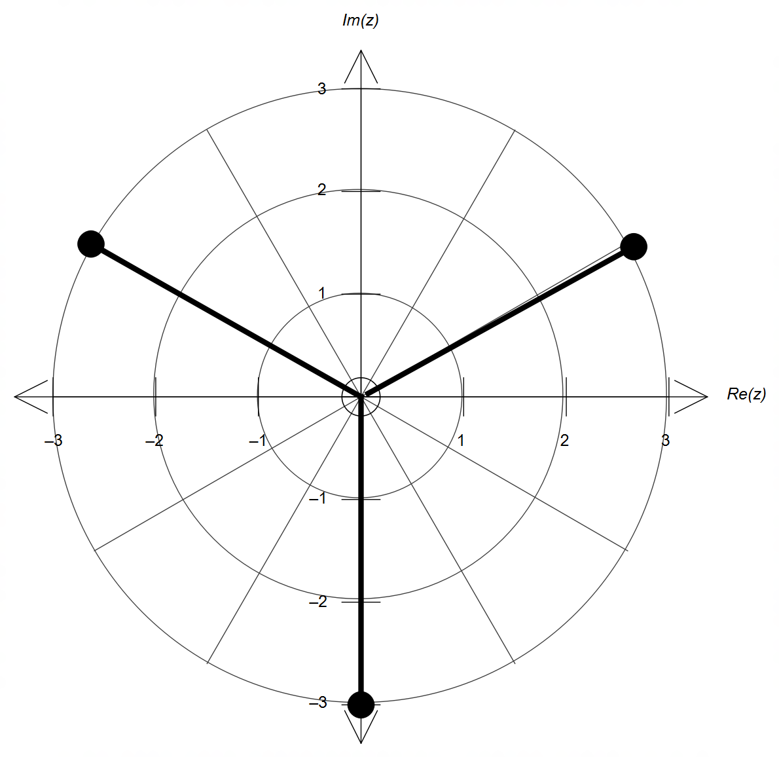 (b)

magnitude = 3

$\frac{2π}{3}$ radians apart

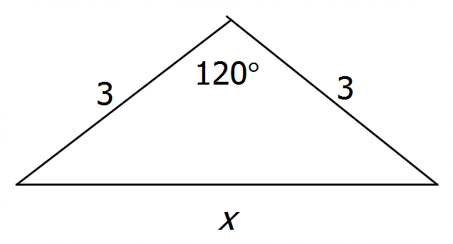 (c)

$x^{2}=9+9-2\left(9\right)\cos{120°}$
$∴x=3\sqrt{3}$
$∴$ perimeter $=9\sqrt{3}$ units, [7]

3. (a) $3a+7=0$
$∴a=-\frac{7}{3}$
(b) $a≠-\frac{7}{3}$
$∴z=\frac{25}{3a+7}, y=\frac{23a+87}{3a+7}, x=\frac{5a+20}{3a+7}$ [6]

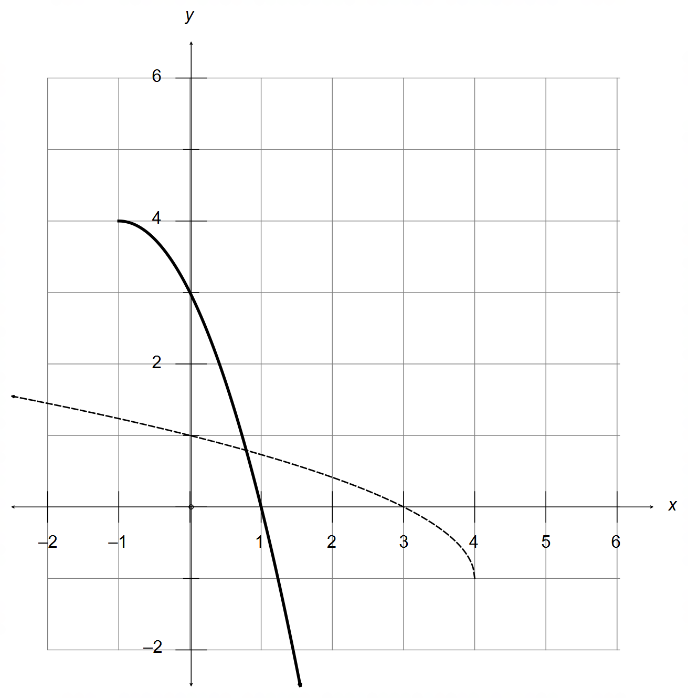4. (a)

intersects f(x)
along the line y=x

correct shape and location

(b) $f^{-1}\left(x\right)=-{\left(x+1\right)}^{2}+4=-x^{2}-2x+3$
Domain $=\left\{x∈R:x≥-1\right\}$

(c) $f\left(g\right)=\sqrt{4-g}-1=\sqrt{x^{2}}-1=\left|x\right|-1$

(d) Condition for composition to exist: $4-g\left(x\right)≥0$
$4-4+x^{2}≥0$
$x^{2}≥0$
$∴x∈R$
$∴$ no changes needed for the domain of $g(x)$
Range $=\left\{y∈R:y≥-1\right\}$ [10]

5. (a) $\vec{FD}=\left(\begin{matrix}-3 \\ 3 \\ 2\end{matrix}\right)$
$∴r=\left(\begin{matrix}3 \\ 0 \\ 0\end{matrix}\right)±λ\left(\begin{matrix}-3 \\ 3 \\ 2\end{matrix}\right)$ OR $=\left(\begin{matrix}0 \\ 3 \\ 2\end{matrix}\right)±λ\left(\begin{matrix}-3 \\ 3 \\ 2\end{matrix}\right)$

(b) Use $\vec{FD}$ as the normal vector of the plane
$∴k=\left(\begin{matrix}-3 \\ 3 \\ 2\end{matrix}\right)∙\left(\begin{matrix}3 \\ 3 \\ 2\end{matrix}\right)=-9+9+4=4$
$∴\left(\begin{matrix}x \\ y \\ z\end{matrix}\right)∙\left(\begin{matrix}-3 \\ 3 \\ 2\end{matrix}\right)=4 → -3x+3y+2z=4$

5. (c) $\left(\begin{matrix}3-3λ \\ 3λ \\ 2λ\end{matrix}\right)∙\left(\begin{matrix}-3 \\ 3 \\ 2\end{matrix}\right)=4 → ∴λ=\frac{13}{22}$
$∴\left(\begin{matrix}3-\frac{39}{22} \\ \frac{39}{22} \\ \frac{26}{22}\end{matrix}\right)=\frac{1}{22}\left(\begin{matrix}27 \\ 39 \\ 26\end{matrix}\right)=\frac{27}{22}i+\frac{39}{22}j+\frac{13}{11}k$

(d) Radius $=p=\frac{1}{2}\left|FD\right|=\frac{1}{2}\left|\begin{matrix}-3 \\ 3 \\ 2\end{matrix}\right|=\frac{\sqrt{22}}{2}$
Centre $=\vec{OF}+\frac{1}{2}\vec{FD}$
$= \left(\begin{matrix}3 \\ 0 \\ 0\end{matrix}\right)+\frac{1}{2}\left(\begin{matrix}-3 \\ 3 \\ 2\end{matrix}\right)=\left(\begin{matrix}\frac{3}{2} \\ \frac{3}{2} \\ 1\end{matrix}\right)$
$∴a=b=\frac{3}{2} c=1$ [12]

6. $y=x+\frac{2}{x+1}$ (after long division or otherwise)

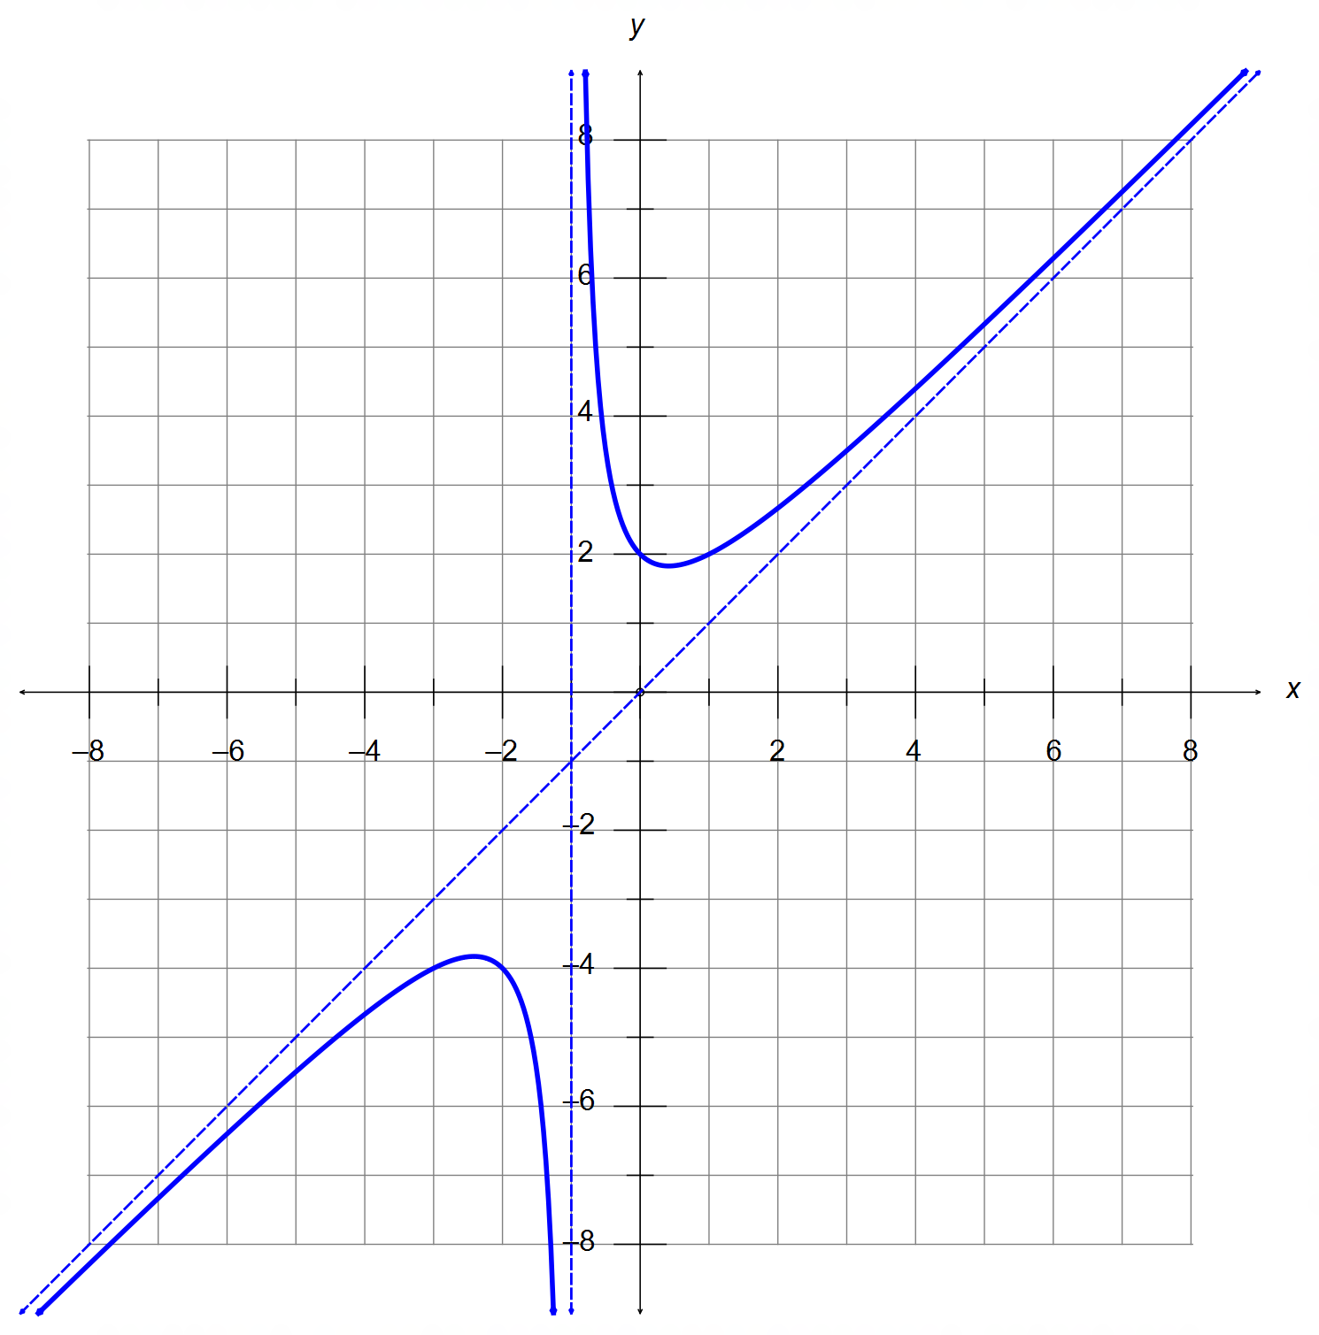

Vertical asymptote x=-1
Oblique asymptote y=x
y intercept at (0,2)
Shape and accuracy

[5]

7. (a) $\left|z\right|=\sqrt{3k^{2}+k^{2}}=2\left|k\right|$ $\left(k≠0\right)$

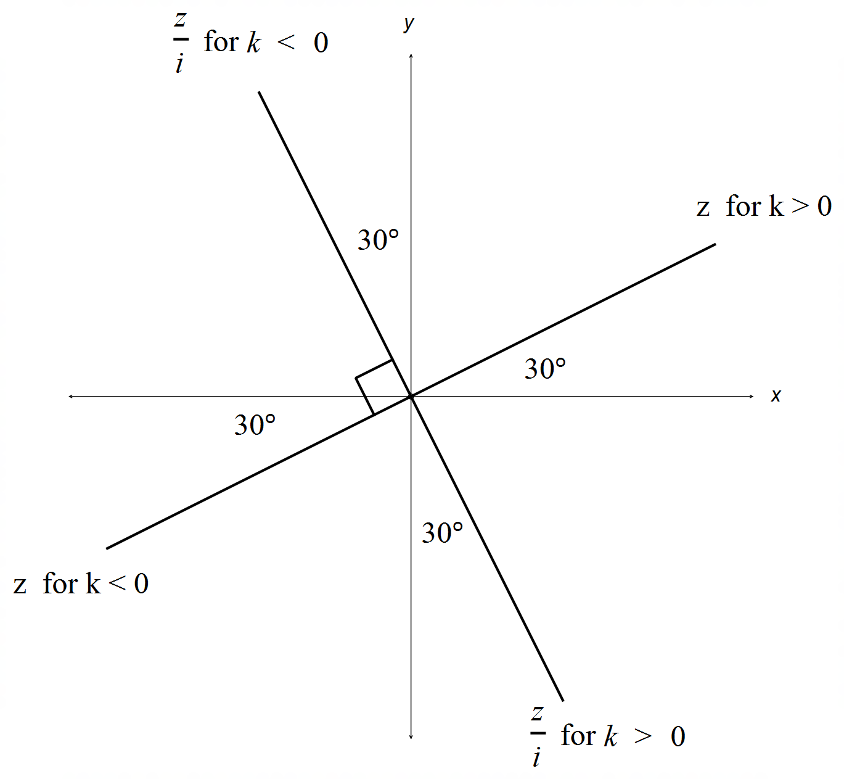 (b)

$\arg\left(z\right)=\frac{π}{6}$ for $k>0$
$\arg\left(z\right)=\frac{-5π}{6}$ for $k<0$

(c) $\arg\left(z\right)=-\frac{π}{3}$ for $k>0$
$\arg\left(z\right)=\frac{2π}{3}$ for $k<0$ [5]

Calculator−Assumed Solutions

8. For ABC to be collinear, AB // AC // BC (any two)
$\vec{AB}=\left(\begin{matrix}4 \\ α-1 \\ -2\end{matrix}\right) \vec{AC}=\left(\begin{matrix}8 \\ 2 \\ β-1\end{matrix}\right)$
$∴\left(\begin{matrix}8 \\ 2 \\ β-1\end{matrix}\right)=k\left(\begin{matrix}4 \\ α-1 \\ -2\end{matrix}\right)$
$∴k=2 → α=2 β=-3$ [4]

9. (a) $ω=\frac{1}{8} → T=\frac{2π}{ω}=\frac{2π}{\frac{1}{8}}=16π=50.27 seconds$

(b) $\frac{d}{dt}r\left(t\right)=\dot{r}\left(t\right)=\frac{5}{4}\cos\left(\frac{t}{8}\right)i+\frac{3}{4}\sin\left(\frac{t}{8}\right)j$

(c) speed $=\left|\dot{r}(t)\right|=\sqrt{\frac{25}{16}\cos^{2}\left(\frac{t}{8}\right)+\frac{9}{16}\sin^{2}\left(\frac{t}{8}\right)}$
$=\sqrt{\left[\frac{9}{16}\cos^{2}\left(\frac{t}{8}\right)+\frac{9}{16}\sin^{2}\left(\frac{t}{8}\right) \right]+\cos^{2}\left(\frac{t}{8}\right) }=\sqrt{\frac{9}{16}+\cos^{2}\left(\frac{t}{8}\right)}$
max speed at $\cos^{2}\left(\frac{t}{8}\right)=1$ or $\cos\left(\frac{t}{8}\right)=±1$
$∴\max{speed}=\frac{5}{4} for t=8nπ, n=0,1,2,…$
$∴r\left(8nπ\right)=±6j$

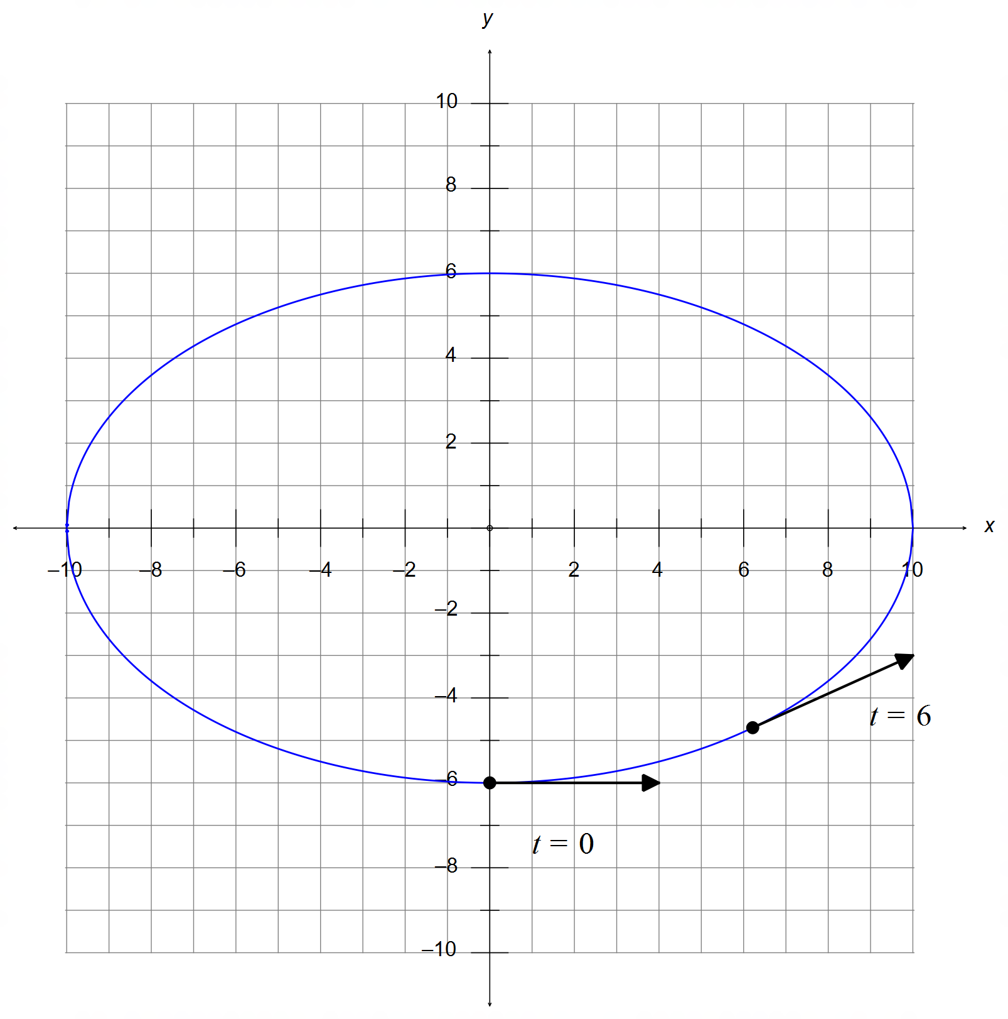 (d) Elliptical path with intercepts $(±10,0)$ and $(0,±6)$

$r\left(0\right)=-6j$
$\dot{r}\left(0\right)=\frac{5}{4}i$
$r\left(6\right)=6.82i-4.39j$
$\dot{r}\left(6\right)=0.91i+0.51j$

[15]
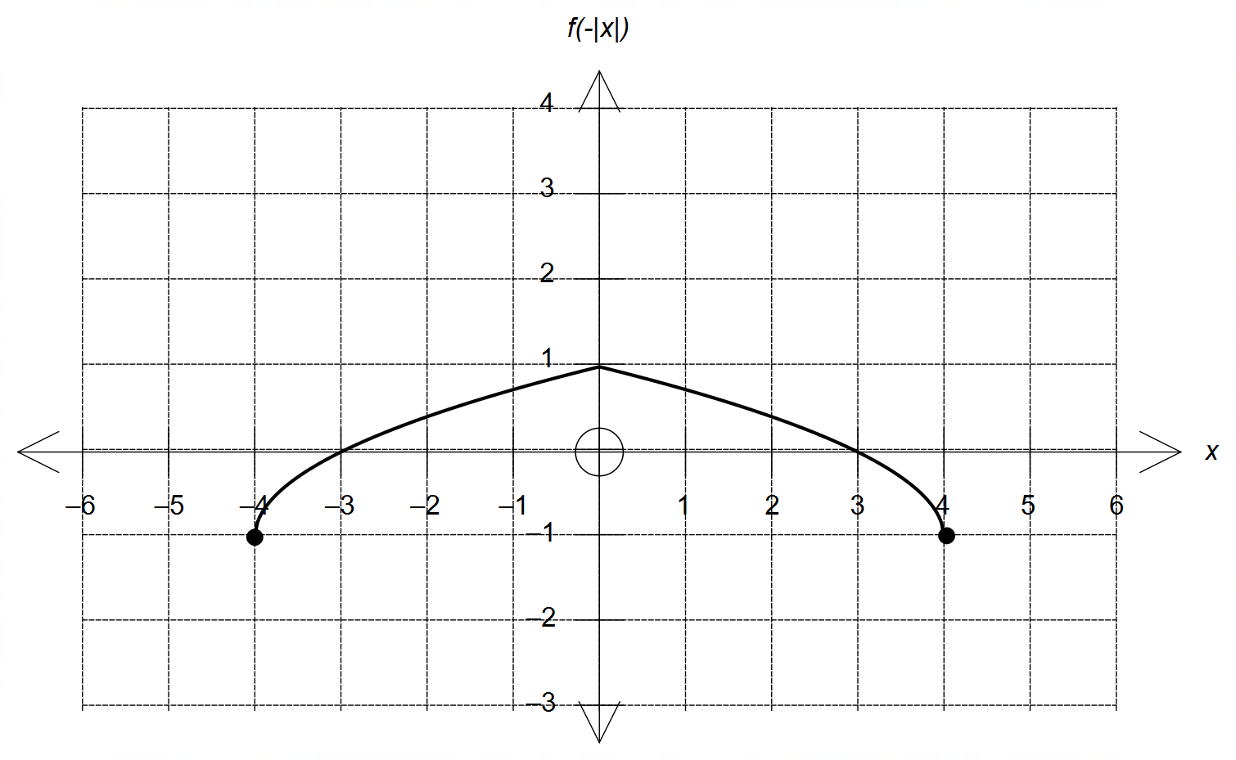10. (a)

Mirror image curve
over the y axis

Location and accuracy

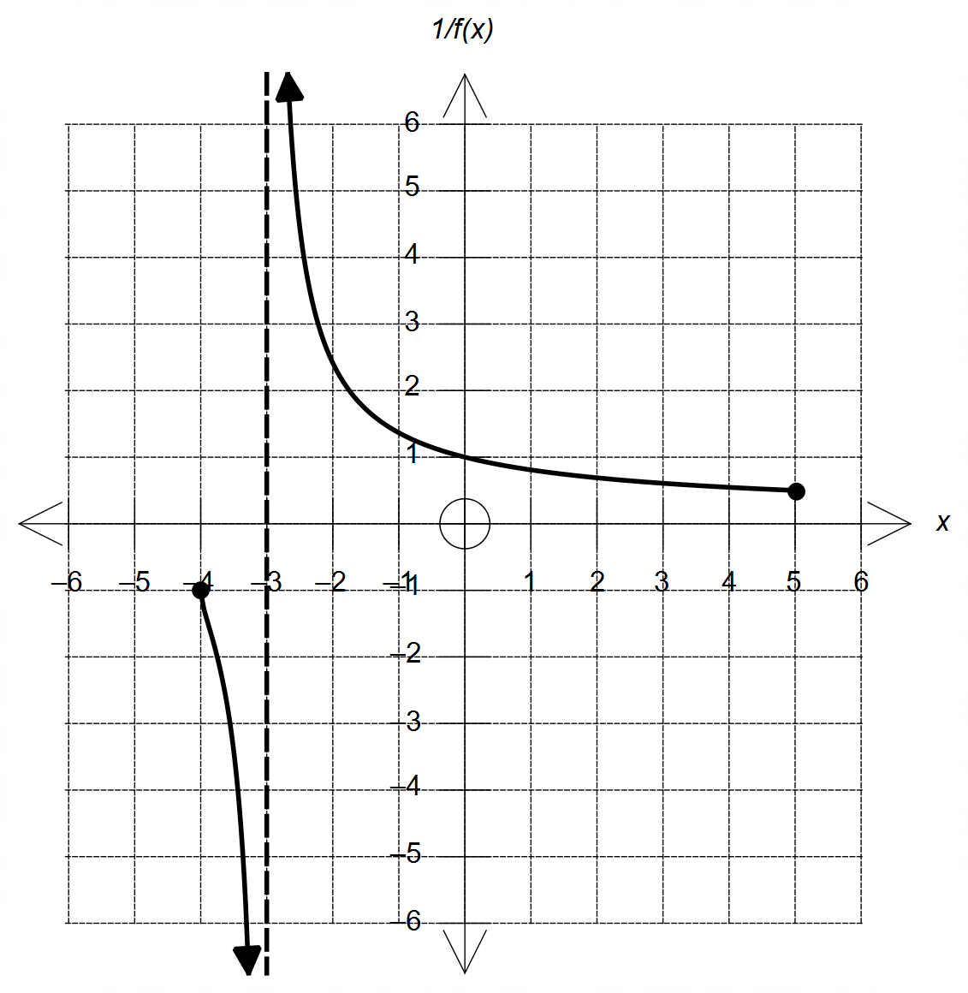 (b)

Vertical asymptote
x = -3

Indicates y →|∞|
as |x| → -3

Correct domain.

crosses f(x) when
y=1 or -1

(c) from the graph below $x=±5$ [8]
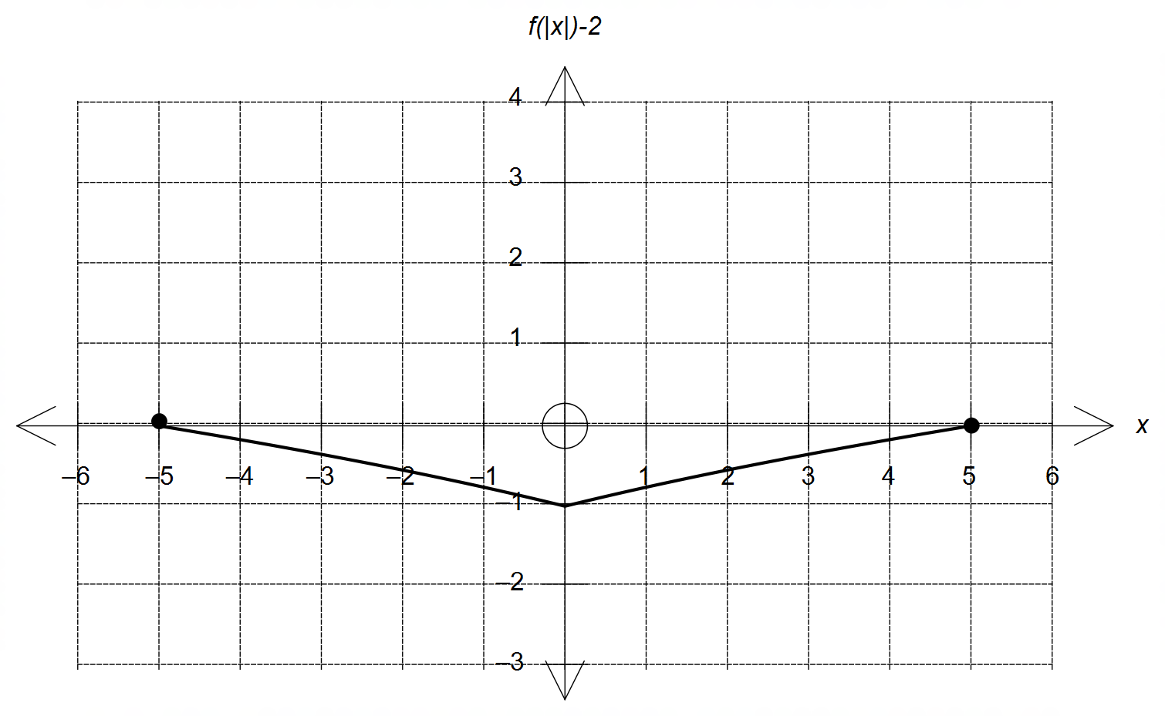

11. (a) (i) $Im\left(z\right)≥-2$
$Im\left(z\right)≤2Re\left(z\right)+1$

(i) $2≤\left|z\right|≤4$
$-\frac{π}{2}≤\arg\left(z\right)≤\frac{π}{10}$

(b) Let $z=x+yi$ and $z≠0$
$\frac{1}{x+yi}-\frac{1}{x-yi}=-\frac{2yi}{x^{2}+y^{2}}=i$
$-2y=x^{2}+y^{2}$
$∴x^{2}+{\left(y+1\right)}^{2}=1$

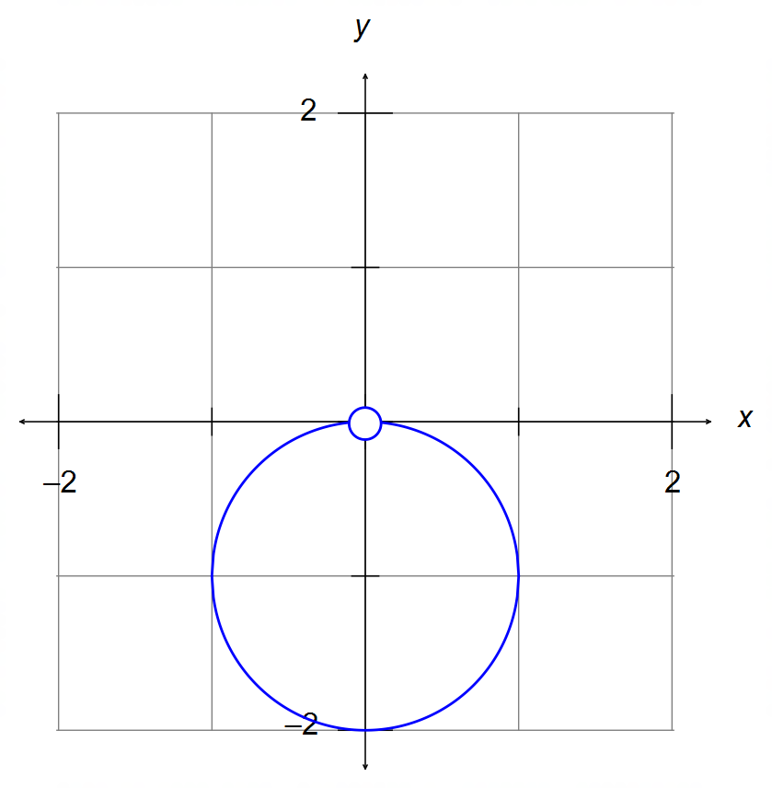

circle centred at
(0,-1) with radius = 1

discontinuity at the origin

[10]

12. (a) $45\min{ → t=\frac{3}{4}}$
$\left(\begin{matrix}-6 \\ 12 \\ -0.6\end{matrix}\right)+\frac{3}{4}v=0$
$∴v=\frac{4}{3}\left(\begin{matrix}6 \\ -12 \\ 0.6\end{matrix}\right)=\left(\begin{matrix}8 \\ -16 \\ 0.8\end{matrix}\right)=8i-16j+0.8k$ km/h

12. (b) $20\min{ → } t=\frac{1}{3}$
$\vec{OA}=O+\frac{1}{3}\left(\begin{matrix}12 \\ -12 \\ 0\end{matrix}\right)=\left(\begin{matrix}4 \\ -4 \\ 0\end{matrix}\right)$
$\vec{OS}=\left(\begin{matrix}-6 \\ 9 \\ -0.6\end{matrix}\right)+\frac{1}{3}\left(\begin{matrix}6 \\ -9 \\ 0.6\end{matrix}\right)=\left(\begin{matrix}-4 \\ 6 \\ -0.4\end{matrix}\right)$
$∴\vec{AS}=\left(\begin{matrix}-4 \\ 6 \\ -0.4\end{matrix}\right)-\left(\begin{matrix}4 \\ -4 \\ 0\end{matrix}\right)=\left(\begin{matrix}-8 \\ 10 \\ -0.4\end{matrix}\right)$
$\left|AS\right|=\left|\begin{matrix}-8 \\ 10 \\ -0.4\end{matrix}\right|=12.81 km$

(c) From $t_{0}=1500$:
$\vec{OT}=\left(\begin{matrix}8 \\ -8 \\ 0\end{matrix}\right)+t\left(\begin{matrix}x \\ y \\ z\end{matrix}\right)$ where $\left|\begin{matrix}x \\ y \\ z\end{matrix}\right|=500$
Condition for collision:
$\vec{OT}=\left(\begin{matrix}8 \\ -8 \\ 0\end{matrix}\right)+t\left(\begin{matrix}x \\ y \\ z\end{matrix}\right)=\left(\begin{matrix}-2 \\ 3 \\ -0.2\end{matrix}\right)+t\left(\begin{matrix}6 \\ -9 \\ 0.6\end{matrix}\right)=\vec{OS}$
$∴ x=6-\frac{10}{t} y=\frac{11}{t}-9 z=0.6-\frac{0.2}{t}$
and ${\left(6-\frac{10}{t}\right)}^{2}+{\left(\frac{11}{t}-9\right)}^{2}+{\left(0.6-\frac{0.2}{t}\right)}^{2}={500}^{2}$
CAS: $t=0.029112$ or 1.75 ~ 2 min (1502hrs)
and $\left(\begin{matrix}x \\ y \\ z\end{matrix}\right)=\left(\begin{matrix}-337.50 \\ 368.85 \\ -6.27\end{matrix}\right)$ km/h [11]

13. (a) $y=-\frac{1}{2}{\left(x-2\right)}^{2}+8=-\frac{x^{2}}{2}+2x+6$
$∴a=-\frac{1}{2} b=2 c=6$
OR
$y=\frac{1}{2}{\left(x-2\right)}^{2}-8=\frac{x^{2}}{2}-2x-6$
$∴a=\frac{1}{2} b=-2 c=-6$
(BOTH solutions must be given)

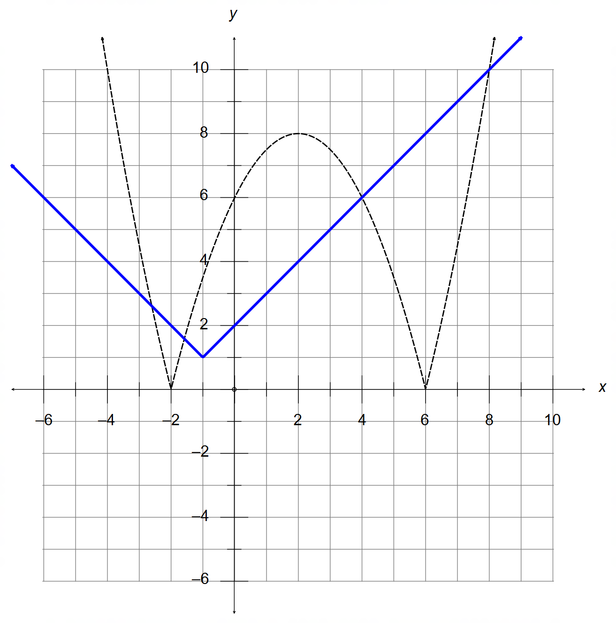13. (b)

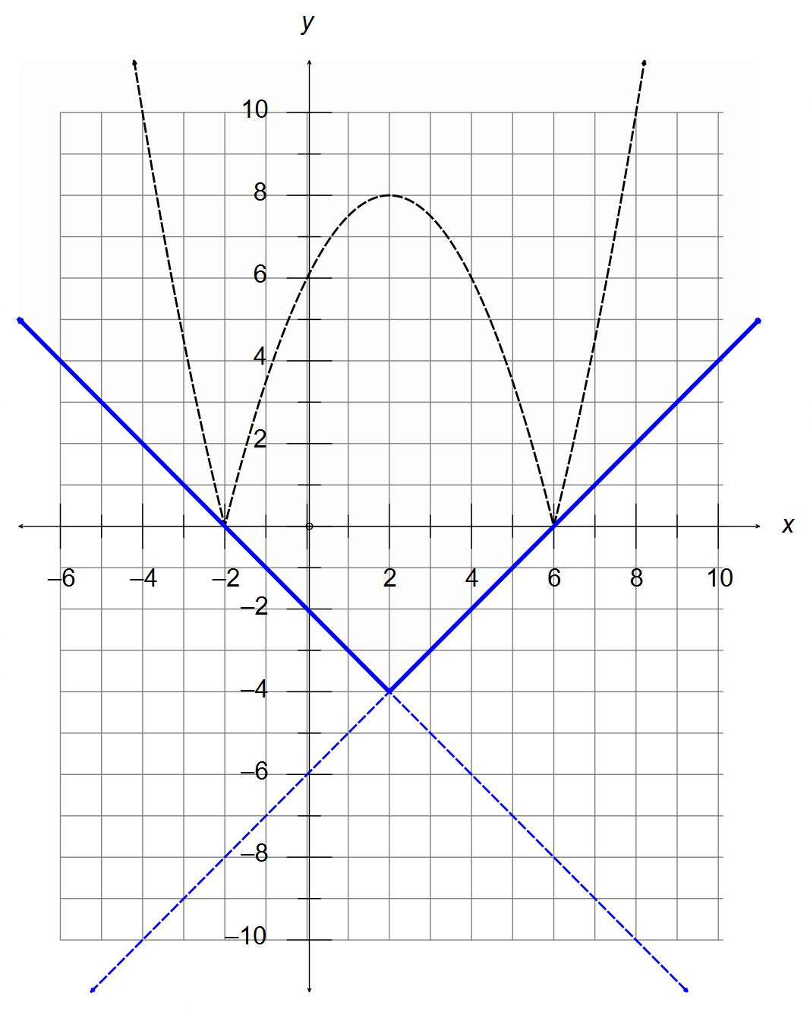 (c)

From the diagram above:

(i) $n≥m-6$
OR $n≥-m-2$
(both solutions must be given)

(ii) $n<m-6$
AND $n<-m-2$ [10]

14. (a) ${\left(x-1\right)}^{2}+{\left(y-1\right)}^{2}+z^{2}=2$
$∴$ centre at $\left(1,1,0\right)$ and radius $=\sqrt{2}$

(b) ${\left(x-1\right)}^{2}+{\left(y-1\right)}^{2}+1^{2}=2$
$∴{\left(x-1\right)}^{2}+{\left(y-1\right)}^{2}=1$
centre at $\left(1, 1, 1\right)$ and radius $=1$

(c) $d=\vec{CP}=\left(\begin{matrix}1 \\ 0 \\ 1\end{matrix}\right)$
$r=\left(\begin{matrix}1 \\ 1 \\ 0\end{matrix}\right)+λ\left(\begin{matrix}1 \\ 0 \\ 1\end{matrix}\right)$
$y=1$ and $x-1=z$

(d) $n=d=\left(\begin{matrix}1 \\ 0 \\ 1\end{matrix}\right)$
$k=n∙\vec{DP}=\left(\begin{matrix}1 \\ 0 \\ 1\end{matrix}\right)∙\left(\begin{matrix}2 \\ 1 \\ 1\end{matrix}\right)=2+0+1=3$
$∴r∙\left(\begin{matrix}1 \\ 0 \\ 1\end{matrix}\right)=3$ [10]

15. (a) See diagram below.
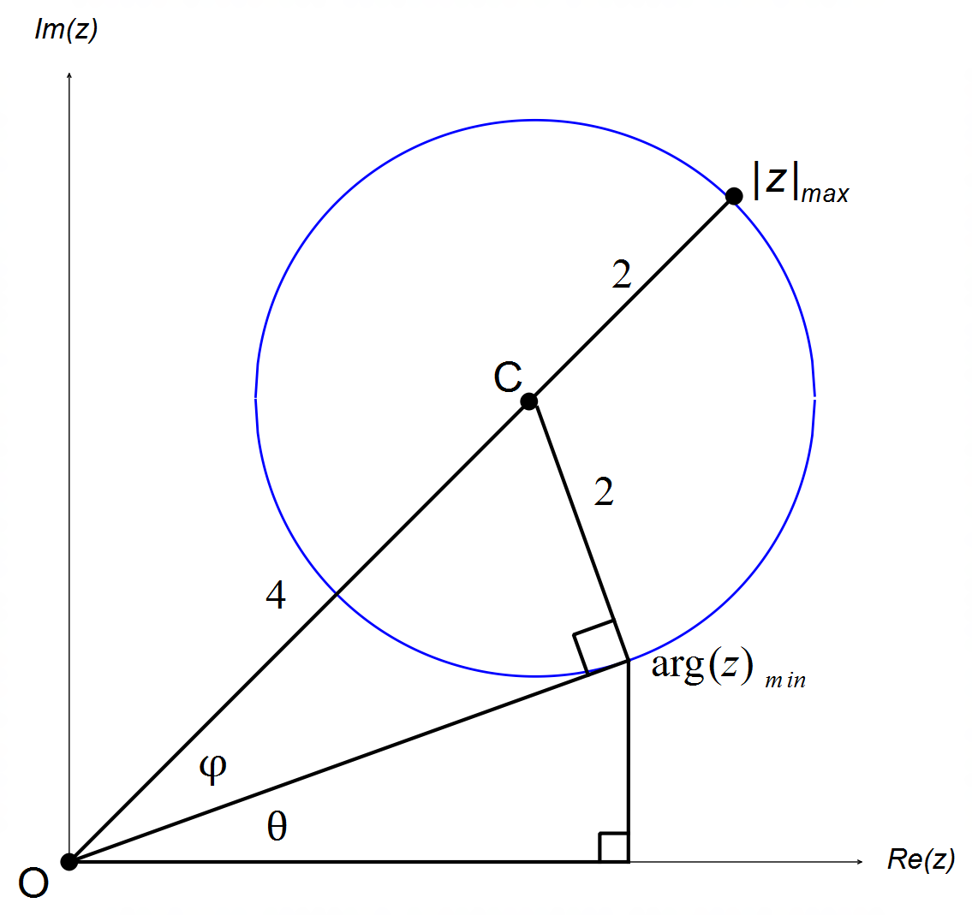

(i) ${\left|z\right|}_{max}=\left|\vec{OC}\right|+r=2\sqrt{2}×\sqrt{2}+2=6$ units

(ii) $\sin{ϕ}=\frac{2}{4} → ϕ=\frac{π}{6}$
$\tan{ \left(ϕ+θ\right)}=\frac{2\sqrt{2}}{2\sqrt{2}}=1 → ϕ+θ=\frac{π}{4}$
$∴θ=\frac{π}{4}-\frac{π}{6}=\frac{π}{12}$

(b) (i) $\cos\left(nθ\right)=\frac{z^{n}+z^{-n}}{2}$
$\sin\left(nθ\right)=\frac{z^{n}-z^{-n}}{2i}$

(ii) $\cos^{3}{θ}={\left(\frac{z^{1}+z^{-1}}{2}\right)}^{3}$
$=\frac{1}{8}\left[z^{3}+3z^{2}z^{-1}+3z^{1}z^{-2}+z^{-3}\right]$
$=\frac{1}{4}\left[\frac{z^{3}+z^{-3}}{2}\right]+\frac{3}{4}\left[\frac{z^{1}+z^{-1}}{2}\right]$
$=\frac{1}{4}\cos\left(3θ\right)+\frac{3}{4}\cos{θ}$ as required [11]

16. (a) $f\left(f\right)=\frac{f+2}{f-1}=\frac{\frac{x+2}{x-1}+2}{\frac{x+2}{x-1}-1}=x$
$∴ f(x)$ is its own inverse

(b) $f\left(x\right)=\frac{x+2}{x-1}=1+\frac{3}{x-1}$
Domain $=\left\{x∈R:x≠1\right\}$
Range $=\left\{y∈R:y≠1\right\}$

(c) Since $y=x$ and $y=-x$ are perpendicular, a reflection
of $y=x$ does not affect the symmetry of $g(x)$ over $y=-x$
therefore, the reflected function continues to be its own inverse

(d) $f^{-1}\left(x\right)=f\left(x\right) → h\left(x\right)=f^{-1}\left(f\left(h\right)\right)$
$=\frac{f\left(h\right)+2}{f\left(h\right)-1}=\frac{\frac{1}{x}+2}{x}$
$∴h\left(x\right)=3x+1$ [10]

17. $P\left(\frac{1}{w}\right)={\left(\frac{1}{w}\right)}^{8n}-{\left(\frac{1}{w}\right)}^{4n}+1=\frac{1}{w^{8n}}-\frac{1}{w^{4n}}+1$
$=\frac{1}{w^{8n}}\left(1-w^{4n}+w^{8n}\right)=\frac{1}{w^{8n}}×P(w)$
$\frac{1}{w^{8n}}×0=0$ $∴\frac{1}{w}$ is also a root of $P(w)$

$P\left(iw\right)={\left(iw\right)}^{8n}-{\left(iw\right)}^{4n}+1=i^{8n}w^{8n}-i^{4n}w^{4n}+1$
$=1×w^{8n}-1×w^{4n}+1=P\left(w\right)=0$
$∴iw$ is also a root of $P(w)$ [6]

18. $\cos{θ}=\frac{x}{2}$
$y=\cos{2θ}=2\cos^{2}{θ}-1$
$∴y=2{\left(\frac{x}{2}\right)}^{2}-1=\frac{x^{2}}{2}-1$

$x=2\cos{θ}, ∴ -2≤x<-2$ Domain $=\left\{x∈R:-2≤x≤2\right\}$
$y=\cos\left(2θ\right)$ Range $=\left\{y∈R: -1≤y≤1\right\}$ [5]

